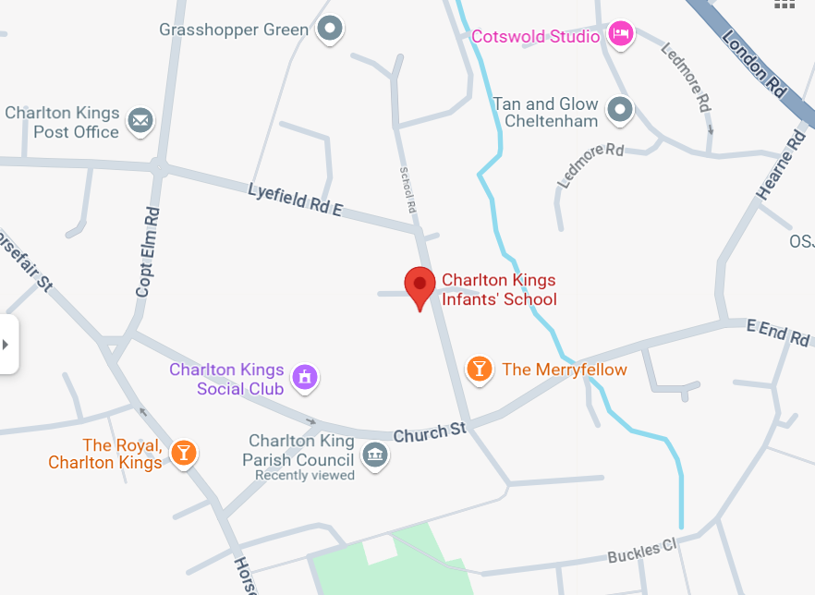

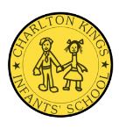
Gold

125 Squadron Car Park
Streets further away
Bronze

The Merryfellow
Lyefield Road East
School Road

Charlton Kings Social Club

Silver
Church Piece Car Park
The Royal

