
THANK YOU !!!

As we come to the end of the summer term, we want to say a huge thank you to all of you who have supported the school and our wider community this year. We couldn’t do it without you

Our Summer Fete this year was an incredible event thanks to all the volunteers, sponsors, donations and support from the entire school community on the day.

Traditional games like hook a duck were as popular as ever, and our tombolas, cakes, fill-a-bag, toys and books were kept very busy in the hall. The bouncy castles were never empty; face paints, tattoos and hair braiding were swamped by excited children and many ice creams, burgers and hot dogs were consumed while the atmosphere at the Bar was buzzing and we were entertained by the Y2 choir and CKIS dancers.

Special mention to Hannah from Care four our Air, and Trish and Mark from Clean Air Cheltenham who came to tell us more about the importance of clean air and how we can contribute towards a better quality air as a community.

There are lots of people to thank, not least our sponsors, BOLT Electrical and Coca Cola European Partners (sponsoring the bar, Charlton Kings Pharmacy and Hudson Rose (bouncy castles) as well as Little Kickers and East Glos Club for bringing their coaches to teach us Football and Squash skills.

A special thank you to those who helped prepare everything in advance, whether that was folding tombola tickets, filling-bags, putting up gazebos, chopping fruits, checking on donations… the list goes on. It is a massive team effort to put on an event like this and we’re grateful to the whole school community for coming together. And we couldn’t complain about the weather!

The total raised on the day was a staggering £4,139 !!!

Newsletter of the Charlton Kings Infants’ School Parents & Friends’ Association. Charity No: 1053722

July 2024
School Daze
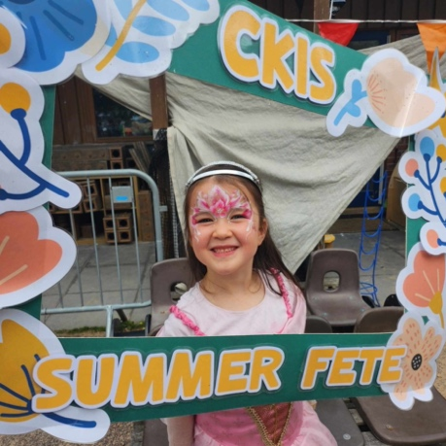

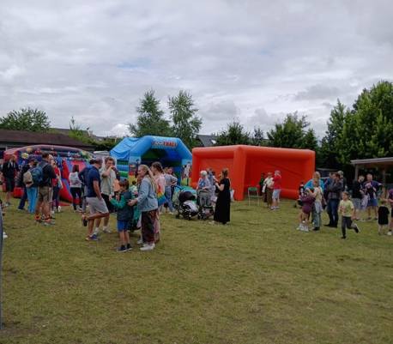



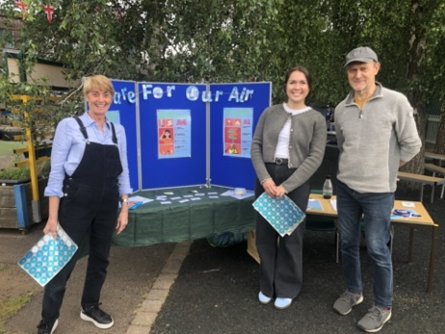

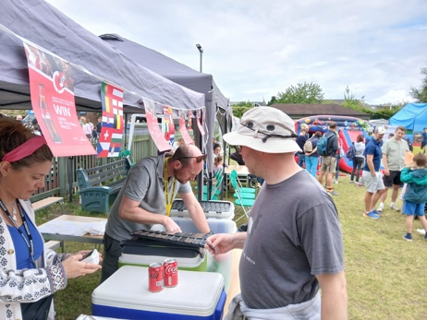

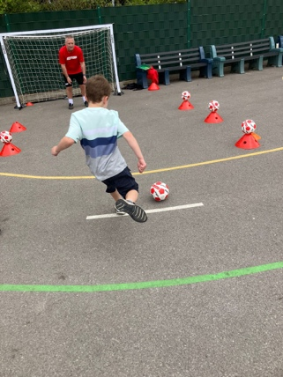
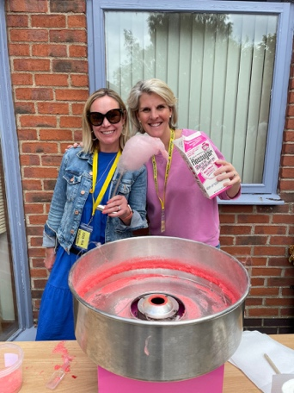
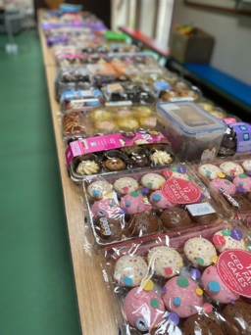
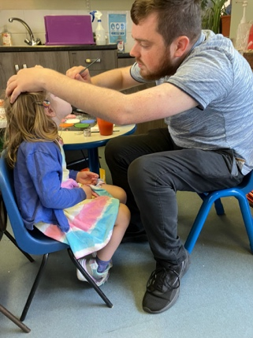
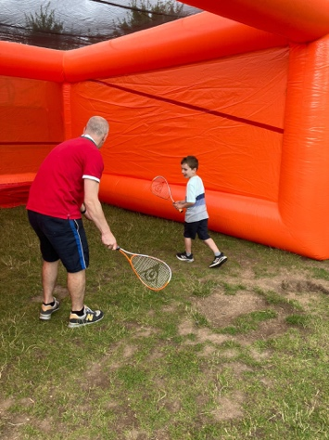










SUMMER RAFFLE

We are very lucky that so many local businesses chose to sponsor our raffle and provided us with brilliant prizes, donations and support….
Huge thanks to all of them!

The raffle was drawn on Monday 1st July and winners were notified during that week.
With all support of our amazing sponsors and CKIS families, our Summer raffle raised £1,603 towards our children’s School Journey.
Thanks for your support !!!








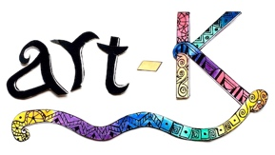


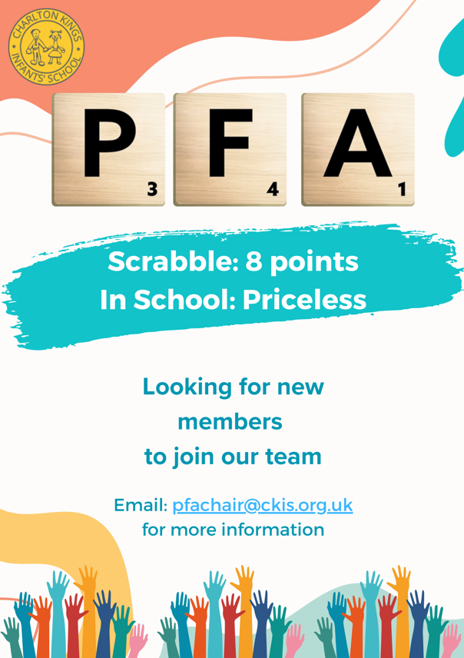
GET INVOLVED !!!

It’s never too late to get involved with the PFA. We will be holding our AGM during the Autumn term in September / October.

There will be committee roles (Chair, Vice-Chair, Vice-secretary, Vice-treasurer) and other positions available (e.g. Christmas card coordinator, communications lead, second-hand uniform coordinator, event coordinators) If you want to help fundraise, organise and be part of the committee, you are very welcome.

Don’t be shy and ask for details if you feel you can give 1 or 2 hours of your time a month or would like to lead a specific project.

Email pfachair@ckis.org.uk with any questions, suggestions or ideas.



Fundraising in these uncertain times is a challenge. If you’d like to support the school by making a donation, or set up a small regular gift… please click here…

As for the rest of the year, we have raised funds through selling Halloween costumes, Christmas cards, beautiful photos of reception children in nativity costumes, our Christmas Story Time event, Charlton Kings Autumn Fayre, “10k in 10 Weeks Challenge”, Car Boot Sale, Pre-loved uniform sales, World book day trail around our village, Party Pack rental and our parents’ Quiz Night.

We don’t have a final number for the entire year as we are waiting for gift aid, and some fees and administrative expenses to be cleared, but we know we have broken a record and fundraised just over £20,000 !!!

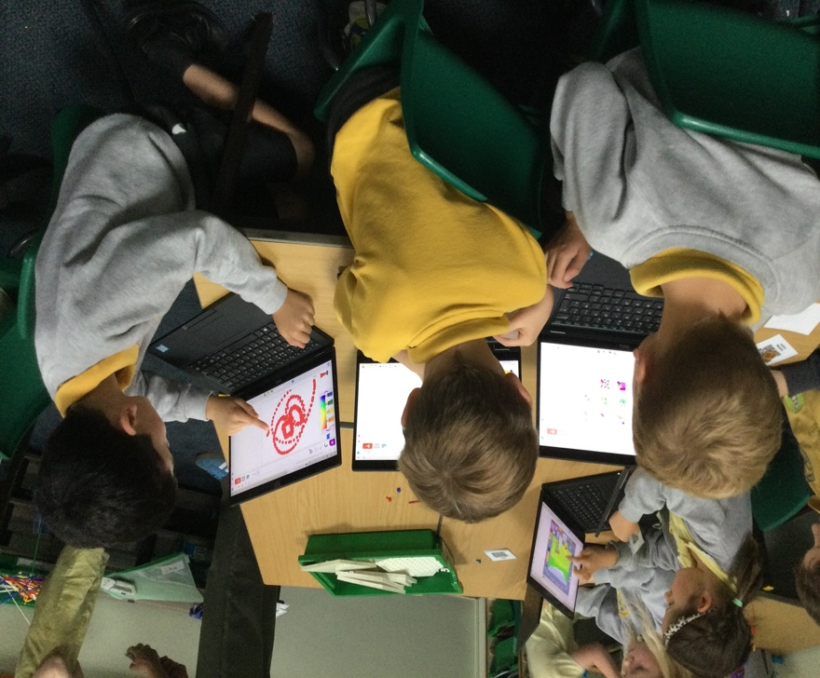
We have spent
the money wisely !!!

The PFA exists to support the school, so that the children have the most memorable, varied and vibrant experience as they embark on the school journey. Last year we were proud to fund our new library provision in Rainbow room. This year we have funded waterproof suits for Forest School, 30 new laptops and 9 new iPads for the children, Dream Reads for all classrooms, gifts for Y2 leavers, magazine subscriptions and ice-creams for the Y2 trip.

We ensure that all PFA investments benefit current and future CKIS children…
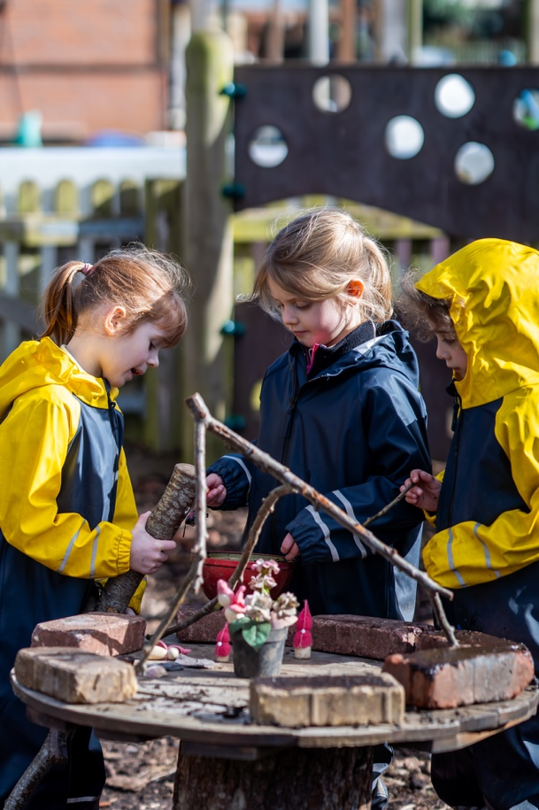

Fundraising in these uncertain times is a challenge. If you’d like to support the school by making a donation, or set up a small regular gift… please click here…

As their children move up to Junior school, I would like to take this opportunity to say a huge thank you to some key members of the PFA who are leaving us this year. Special mention to our Class Rep Lead Simone Morris who has been instrumental at every single event, as well as current Y2 class reps Daniela Landaeta and Rachel Tozza, and AdHoc volunteers Charlie Morgan, Kate Clover, Carly GS, Gustavo Landaeta, Nicky Carlyle, Rebecca Booth, Sachi, Naveen, Charlotte MW and Vicky Fitzgerald who’ve all given so much time and energy into running various activities over the years.

It's my last year as Chair and in the Autumn we will vote a new chief-organiser and spinner of plates!! It’s been a huge privilege being part of the PFA team for three years through challenging times but with lots of fun and laughter along the way, I’m very proud of our school community and will keep supporting the PFA from behind the scenes as needed. Please come to our AGM and help us to choose the new Chair.

We want to wish all our school families a healthy, safe and happy summer.

See you in September !
Tatiana and the team

PRE - LOVED UNIFORM !

If your child is leaving school and you have uniform to donate, please drop it to school before the end of the term or contact pfchair@ckis.org.uk to arrange collection.

Alternatively, feel free to sell it via
“CKIS PFA For Sale and Wanted” Facebook group.

A donation will be gratefully received.
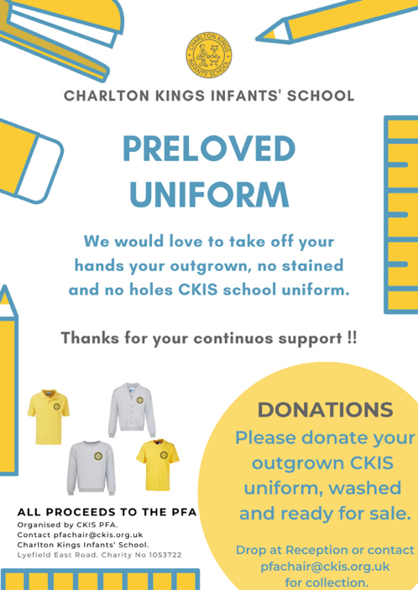

Get in Touch
Find Us & Follow Us
Fundraising

CLICK ON THE LOGOS TO KNOW MORE
The following websites will donate a percentage of your fund if you shop via their sites…



CLICK ON THE LOGO TO KNOW MORE

For more information, please contact your PFA class rep or:
CORE PFA TEAM CONTACTS:
Tatiana Artahona | pfachair@ckis.org.uk

Let us know your comments, questions, or thoughts… provide suggestions or ideas.
Thanks in advance !!!



Fundraising in these uncertain times is a challenge. If you’d like to support the school by making a donation, or set up a small regular gift… please click here…

